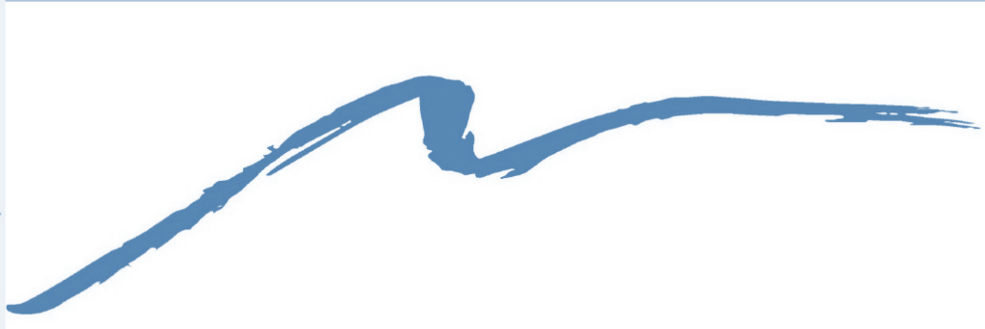
ORTHODONTICS FOR CHILDREN & ADULTS

21 Lafayette Rd 651 County Rd. 517
Suite D Vernon Twp
Sparta, NJ 07871 Sussex, NJ 07461
(973) 729-9923 (973) 764-2266

Skylands Orthodontics
Krystian Jarosz, DMD, MDS

Patient HIPAA Awareness

With my permission, Skylands Orthodontics may use and disclose protected health information (PHI) about me to carry out treatment, payment and healthcare operations (TPO). Please refer to Skyland Orthodontics Notice of Privacy Practices for a more complete description of such uses and disclosures.
I have the right to review the Notice of Privacy Practices prior to signing this consent.
Skylands Orthodontics reserves the right to revise its Notice of Privacy Practices at anytime. A revised Notice of Privacy Practices may be obtained by forwarding a written request to the Privacy Officer.
With my permission, the office of Skylands Orthodontics may call my home or other designated locations and leave a message on voice mail or in person in reference to any items that assist the practice in carrying out TPO, such as appointment reminders, insurance items and any call pertaining to my clinical care, including laboratory results, among others.
With my permission, the office of Skylands Orthodontics may mail to my home or other designated locations any items that assist the practice in carrying out TPO, such as appointment reminder cards and patient statements. This also includes texting appointment reminders.
With my permission, the office of Skylands Orthodontics may e-mail to my home or other designated location any items that assist the practice in carrying out TPO, such as appointment reminder cards and patient statements. I have the right to request that Skylands Orthodontics restrict how it uses or discloses my PHI to carry out TPO. However, the practice is not required to agree to my requested restrictions, but if it does, it is bound by this agreement.
By signing this, I am allowing Skylands Orthodontics to use and disclose my PHI for TPO.
I may revoke my consent in writing except to the extent that the practice has already made disclosures in reliance upon my prior consent.
Signature of Patient or Legal Guardian_________________________________
Print Name of Patient or Legal Guardian________________________ Date_____________________

